Mendel’s Laws of Inheritance

Gregor Johann Mendel was a scientist who is recognized as the Father and Founder of genetics. Mendel conducted many experiments on the pea plant (Pisum sativum) between 1856 and 1863. He studied the results of the experiments and deducted many observations. Thus, laws of inheritance or Mendel’s laws of inheritance came into existence. Mendel’s Laws of Inheritance are certain laws or statements which describe the mechanism of transmission of certain characteristics from one generation to another in an organism.

The terminology of Mendelian inheritance
Gregor Mendel is famous for discovering “particulate inheritance” or the idea that hereditary elements are passed on in discrete units rather than “blended” together at each new generation. Today we call those discrete units genes.
- A gene is a hereditary factor that determines (or influences) a particular trait. A gene is comprised of a specific DNA sequence and is located on a specific region of a specific chromosome. Because of its specific location, a gene can also be called a genetic locus.
- An allele is a particular variant of a gene, in the same way that chocolate and vanilla are particular variants of ice cream.
- An organism’s genotype is the particular collection of alleles found in its DNA. An organism with two of the same alleles for a particular gene is homozygous at that locus; an organism with two different alleles for a particular gene is heterozygous at that locus.
- An organism’s phenotype is its observable traits. An organism can have a heterozygous at a particular locus but have a phenotype that looks like only one of the two alleles. This is because some alleles mask the appearance of others in a dominant/recessive pattern.
- A dominant allele produces its phenotype whether the organism is homozygous or heterozygous at that locus. For example, in humans the allele for brown eyes is dominant to the allele for blue eyes, so a person who is heterozygous at the eye color locus will have brown eyes.
- A recessive allele produces its phenotype only when homozygous at the locus; its phenotype is masked if the locus is heterozygous. For example, a person must have two copies of the blue eye color allele to have blue eyes.

Laws of Inheritance
Mendel proposed three laws:
- Law of Dominance
- The Law of Segregation
- Law of independent assortment
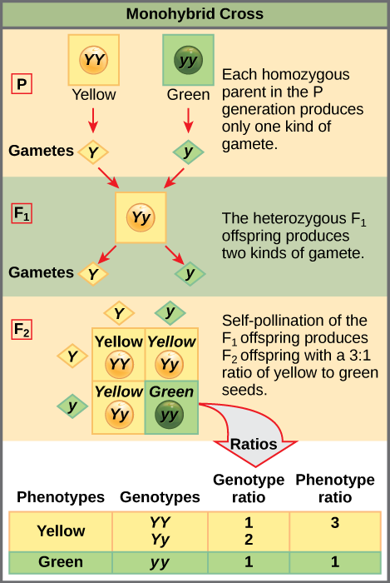
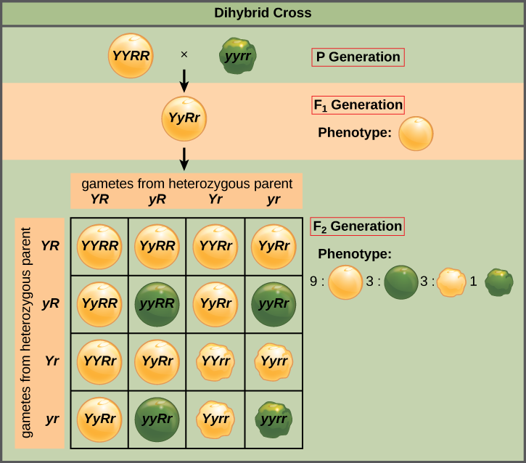
- Law of Dominance
The statement of Law of Dominance states that:
“When two homozygous individuals with one or more sets of contrasting characters are crossed, the alleles (characters) that appear in the F1F1 are dominant and those which do not appear in the F1F1 are recessive”.
According to the law of dominance:
I. The characters are controlled by discrete units called factors, which are now called alleles.
II. Alleles occur in pairs.
III. Out of two alleles, only one allele expresses itself in the hybrid and prevents the expression of the other allele. The allele which expresses itself in the hybrid is called dominant allele and the other allele which is unable to express in the hybrid is called recessive allele.
- Law of Segregation
According to the law of segregation, two alleles of a gene controlling each character stay together in the individual but during gamete formation by meiosis, the alleles of a pair segregate or separate from each other so that a gamete carries only one allele of a character. Or, in other words “When hybrid (F1)(F1) forms gametes, the alleles segregate from each other and enter in different gametes”.
Law of Segregation is also known as Law of Purity of Gametes because one gamete contains only one allele from each parent, so all gametes are always pure.
- Law of Independent Assortment
According to the law of independent assortment, the alleles of two pairs of traits separate independently of each other during gamete or spore formation and get randomly rearranged in the offspring at the time of fertilisation, producing both parental and new combination of traits.
Or in other words “When a hybrid possessing two (or more) pairs of contrasting factors (alleles) forms gametes, the factors in each pair segregate independently of the other pair”.

